1. Context
[Summary of institution situation & potential interest]

2. Institution General Info
Institution name
Address
Zip code / City
Region / Country
Website
Part of a group? or other related hospitals | - No | - Yes, specify
Total employees (in ETP)
Accreditation
Total beds
Number admissions/year
Department from PI
Wards using artificial nutrition | - Oncology  - GI  - Geriatric | - Others: specify
Targeted ward | - ICU | - Others: specify
Ward – # beds
Ward – average length of stay (in days)
Ward - # patients/year
Ward - # patients w/ stay >72h
Burn ward & beds | - No | - Yes, # beds?
[Comments]

3. Staff & Stakeholders
General Manager / CEO
CFO
CIO
Medical KOL
Head of Dietetics
Head of Nurses
Legal Representative
DPO / Security Data Officer
Quality Officer
[Comments]

4. Clinical & nutrition

4.1 Nutrition Staff & R&R
X-functional nutrition team | - No → indicate who is prescribing the clinical nutrition | - Yes → Complete table hereunder

X functional nutrition team names | Specialty | Dietician dedicated to targeted ward | ESPEN Members | ASPEN members
 |  | - Yes | - Yes | - Yes
 |  | - Yes | - Yes | - Yes
 |  | - Yes | - Yes | - Yes

 |  |  | SOP describing the practice available?
Who screens patient malnutrition | - Doctors  - Dietician | - Other, specify.  - Not done | - Yes
Who determines the nutrition target | - Doctors  - Dietician | - Other, specify.  - Not done | - Yes
Who reviews & prescribes clinical nutrition? | - Doctors  - Dietician | - Other, specify.  - Not done | - Yes
Who assess patient nutritional status | - Doctors  - Dietician | - Other, specify.  - Not done | - Yes
Who put in place clinical nutrition? | - Doctors  - Dietician  - Nurse | - Other, specify.  - Not done | - Yes
Who collects the clinical nutrition data? | - Doctors  - Dietician  - Nurse | - Other, specify.  - Not done | - Yes

Nutrition data collection | Frequency? | Time spent per patient per day (min)?
[Comments]

4.2 Nutrition Challenges & Best practices
Do you use a clinical nutrition management system | - No | - Yes, Specify
Do you screen patient to identify malnutrition risk at entry in the ward? (NRS-2002 / MUST / MNA, …) | - No | - Yes, specify which one and when
Do you use assess patient malnutrition during their stay in the ward? (SGA…) | - No | - Yes, specify which one and how often
Do you have a standard procedure describing this decision process to prescribe clinical nutrition in your ward? | - No, can you describe it | - Yes, can you share it with us ?
Do you define nutrition target per patient per day? | - No | - Yes, specify how
Do you estimate/calculate the nutrition needs? | - No | - Yes, specify how
How do you monitor real nutrition delivery in your hospital? | - No | - Yes, specify how
Do you collect / document the delivered volumes for enteral and parenteral nutrition? | - No | - Yes, specify how and how often
For your ward, can you estimate time & resources required per day for clinical nutrition management (including screening, assessment, need estimation/calculation, prescription, monitoring)? | - No | - Yes, specify
What are the main consequences of not achieving nutrition target in your ward?
What are the key parameters to consider performing an efficient nutrition monitoring?
What are the existing barriers or challenges to improve the management of nutrition therapies?

How do you consider your clinical nutrition practices? | Good | Not good | Not known | If consider as not good, why?
Nutrition awareness in all wards?
Clinical nutrition management?
Clinical nutrition prescription?
Actual delivered nutrition versus patient needs?
Actual delivered nutrition versus prescription?
Close and personalized follow-up per patient?
Availability of clinical nutrition information?
Clinical nutrition Information used to take actions?
Clinical nutrition Information used to take decisions?
Clinical nutrition Information efficiently shared?
[Other criteria]
[Comments]

4.3 Nutrition Pumps (in targeted ward)
# Enteral pumps / bed
# Parenteral pumps / bed

Type of pumps | # pumps (fleet) | Brand | Model | Nutrition Data Collection
 |  |  |  | No | Manual on paper | Manual, then encode on software (SW) | Automatic (software SW)
[Enteral] |  |  |  |  |  | - [Enter SW name] | - [Enter SW name]
[Enteral] |  |  |  |  |  | - [Enter SW name] | - [Enter SW name]
[Parenteral] |  |  |  |  |  | - [Enter SW name] | - [Enter SW name]
[Parenteral] |  |  |  |  |  | - [Enter SW name] | - [Enter SW name]
[Comments]

4.4 Nutrition Products (in targeted ward)
Product type | Brand or description | Customized
Product type | Brand or description | No | Yes % used versus brand
[Enteral] |  |  | - [% used]
[Enteral] |  |  | - [% used]
[Parenteral] |  |  | - [% used]
[Parenteral] |  |  | - [% used]
[IV products bringing kcal] |  |  | - [% used]
[Other products] |  |  | - [% used]
[Comments]

5. Institution Information Systems

5.1 IT Staff & R&R
 | Contact name | Availability for Nu/Fe integration project
Infrastructure, Network, Wi-Fi Responsible |  | - Yes
Software applications Responsible | Thomas Debieve | - Yes
- EHR responsible | Thomas Debieve | - Yes
- LIMS responsible | Thomas Debieve | - Yes
- EAI responsible | Thomas Debieve | - Yes
IT assets responsible (Tel / barcode / PC) |  | - Yes
IT Security responsible |  | - Yes
IT project responsible |  | - Yes

# IT integration projects done in last 5-7 years
Describe type of integration | Internal Software Development  Integration of external application into our information system  Development of inter-application connectors/interfaces  Development and scripting of internal modules into our medical patient record application
Type of API used | - HL7 : used  - FHIR  - Specific connector  - Watch folder (XML, CSV…) : used
Integration with which software applications (see list hereunder) ? | - Cfr diagram at 5.2
[Comments]

5.2 Software applications used by the institution.
For what | Software applications | Name | Provider | Relationship with provider
Patient administrative information | EHR / PDMS | WISH/AS400 | IBM | - Good support  - Difficult  - Will charge for any support
Nutrition specific information | Nutrition management software | Omnipro | Zorgi | - Good support  - Difficult  - Will charge for any support
Nutrition Prescription | Prescription software | Omnipro | Zorgi | - Good support  - Difficult  - Will charge for any support
Physiological patient data | Nurse file software | H+/EPR | Zorgi | - Good support  - Difficult  - Will charge for any support
Labs results | LIMS | Molis | CGM | - Good support  - Difficult  - Will charge for any support
Pump delivered volume | Specific Pump software | / | / | - Good support  - Difficult  - Will charge for any support
Specific ward information | Specific ward software | / | / | - Good support  - Difficult  - Will charge for any support
Data exchange | Institution EAI | Internal Development
Any other software | Any other software | > 200 software implemented in our hospitals | / | - Good support  - Difficult  - Will charge for any support
[Comments]

5.2 Current data flow between institution software applications
- Ask for an interaction diagram between the different Software applications.

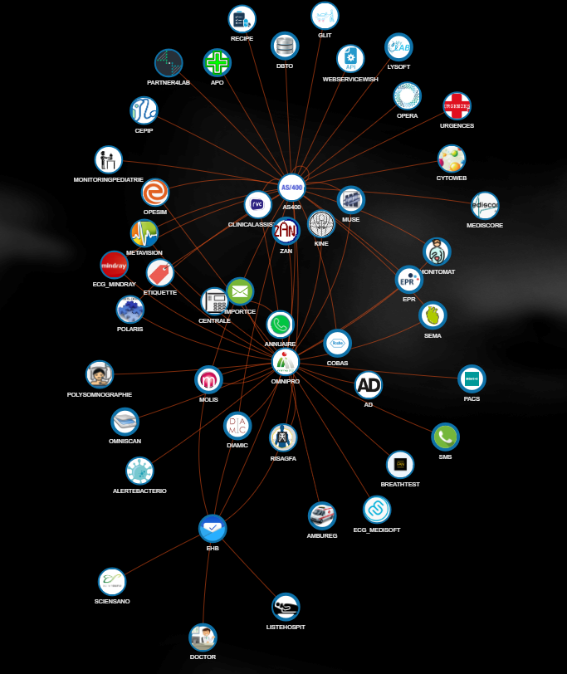

5.3 Data availability & source
Data category | Not available | Paper only | Digitally | Notes (in case of Digitally, indicate the application name from previous list)
Users | - Institution AD integration required? |  |  | AD available
Patient administrative data |  |  |  | WISH/AS400
Admission data |  |  |  | WISH/AS400
Physiological patient data |  |  |  | EPR / H+
Lab analysis |  |  |  | MOLIS
EN delivered volumes |  |  |  | /
PN delivered volumes |  |  |  | /
Other nutrition product delivered volumes |  |  |  | OMNIPRO (patient medical record)
OTHER DATA (optional)
Users  (no AD integration required) |  |  |  | /
Screening & assessment |  |  |  | /
Theoretical target |  |  |  | /
Prescription |  |  |  | EPR /+ and internal development
[Comments]

5.4 Institution infrastructure
Type | Dim3 specifications | Comments
# VM | - 3 VM : Control / production / Test
Applications VM | - Cloud based, specify | In case application VM and/or DB server cannot be cloud based, please specify
DB Server | - Cloud based, specify
Kubernetes server | - Yes
VM OS type | - Linux RedHat
DB type | - MySQL | MySQL, Oracle, PostGreSQL
Wi-Fi for IoT | - WPA2-Personal  - WPA2-Enterprise ENT_PEAP_MSCHAPV2  - WPA2-Enterprise ENT_TTLS_MSCHAPV2
Browsers used (specify version)  No internet explorer | - Google Chrome v?  - Edge Chromium v?  - Firefox v?  - Safari v?
PC available closed to patient beds | - Yes
PC OS | - Windows v?
Smartphone  No windows phone | - iPhone v?  - Android type & v?
Any other limitation or security requirements from institution?
[Comments]

5.4 Development, testing & operations
Can the institution share the specifications on the SW used (related to nutrition - see above) ?
- Yes
- No
Tasks - who will? | Dim3 requirements - Responsibility | Documentation available from institution? | Comments
…develop the adaptor(s) | - Dim3 w/ support of the institution | - Yes, from previous adaptor development | No adaptor currently
…provide servers as per Dim3 requirements | - Dim3 (cloud)  - Institution (cloud or on premise | - Yes
…. configure the network (opening port, firewall…) | - Institution | - Yes
… install the Kubernetes cluster on server (on premise) | - Institution (on premise) | - Yes
… install Nu/Fe on server | - Dim3 w/ support of the institution | - Yes
…provide testing environment and data set | - Institution w/ support of Dim3 | - Yes
… activate of Wi-Fi IoT & whitelisting | - Institution | - Yes
… test and execute the VTP | - Dim3 w/ support of the institution | - Yes, from previous development
… provide the training | - Dim3 w/ support of the institution | - Yes, from previous development
… be responsible of logging & monitoring | - Institution logging  - Datadog monitoring by Dim3 | - Yes
…be responsible for data transfer policy (retention period, ACK, alert messages…) | - Institution | - Yes
… be responsible for backup policy (DB, VM) | - Institution | - Yes
… be responsible for software updates policy (bug fixes, patches, intermediate release) | - Institution | - Yes
… provide Service Support | - T1 are institution’s clinical key users / T2 are institution’s internal IT engineers / T3 at Dim3  - Use of Jira Service Desk to report issue to Dim3  - Dim3 remote access if needed | - Yes

